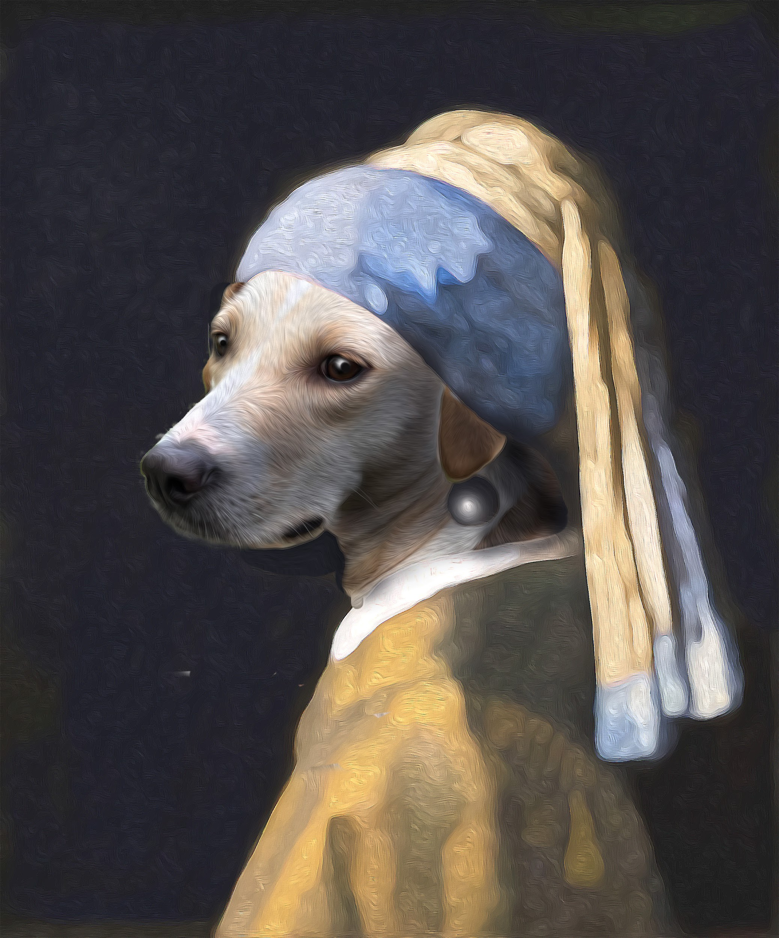
Puppy with A Pearl Earring
with Timothy Peterson
Psss! Cats are also welcome!

Learn the painting process of Johannes Vermeer, one of the most famous painters in history, while adding your own furry friend to the masterpiece "Girl with a Pearl Earring."
In this class, you will learn about Vermeer's unique painting techniques, including his use of light, color, and perspective. You will also learn how to create a portrait of your four footed family member.
By the end of the class, you will have created a beautiful painting that is a tribute to your cherished and beloved pet.
This class is perfect for anyone who loves art, painting, or animals.
Sign up today and start creating your masterpiece!
This workshop runs in two sessions.
The medium of this course can be Acrylic or Oil.
Oil medium supplied, which is 50/50, linseed oil and odorless thinner.
If you prefer your own paints, please feel free to bring them.

Date: Saturday, XXX and Saturday XXX
Time: XXam-XXpm
Cost: $150.

